

UNIVERSIDAD NACIONAL AUTÓNOMA DE MÉXICO

FACULTAD DE INGENIERÍA

Subject: Computación Gráfica e Interacción Humano Computadora

Group: 5

Semester: 2022-2

Development Manual

Deadline: 26/05/2022

Professor: José Roque Román Guadarrama

Students:

* Colin Santos Luis Froylan
* Najera Noyola Karla Andrea

# What is this manual?

This manual describes the realization of the project based on the resources used, the logic behind it, the programming process of this software and the rubrics requested for this project, especially for the "Elementos a incluir dentro del escenario" item.

This manual is not intended to give information about how to use the program (that can be read from the user manual) nor is it intended to help configure the build environment (that is included in the configuration manual).

# Software Information

We have different items to cover within the category of "Elements to include in the scenario", which are the following:

* Geometry
* Avatar
* Route
* Lightning
* Animation
* Own element
* Audio

Below we present each rubric item with its solutions within our project.

# Geometry and Avatar

The Geometry category takes into account the visible models on the stage and their textures. The Avatar category considers that the proposed avatars (Morgana and Futaba, in this case) are created in a hierarchical way.

In our case, all the models (except the floor) were made by us, even the textures, with a few exceptions.

Among the exceptions, there is the blue skybox, which was given to us by Professor Sergio Valencia in the subject laboratory, but it is worth mentioning that we modified its appearance a little so that it is consistent with the voxel-art style, and the same can be said of the model of the floor, which was given to us by Professor Sergio, but we put a texture made from scratch. Likewise, the orange skybox was taken from the following link <https://www.pngwing.com/es/free-png-pplmt> where an author is not specified, although we also modified it to give it a more orange color tone.

All the other models are our own creation, with the help of the MagicaVoxel tool, which allows us to model in voxel-art, export our models to .obj and also obtain their materials and textures, which made this part of the development a lot easier. Unfortunately in MagicaVoxel, for small models, there are issues with the model origin, but all of these issues were solved using the 3ds Max 2023 software.

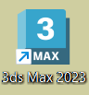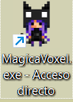

Shortcuts to MagicaVoxel and 3ds Max 2023 programs.

Once our models were exported and their origins were corrected, it was possible to incorporate them into the project. All the models are located inside the project folder “resources < objects”, although they are all in different folders.

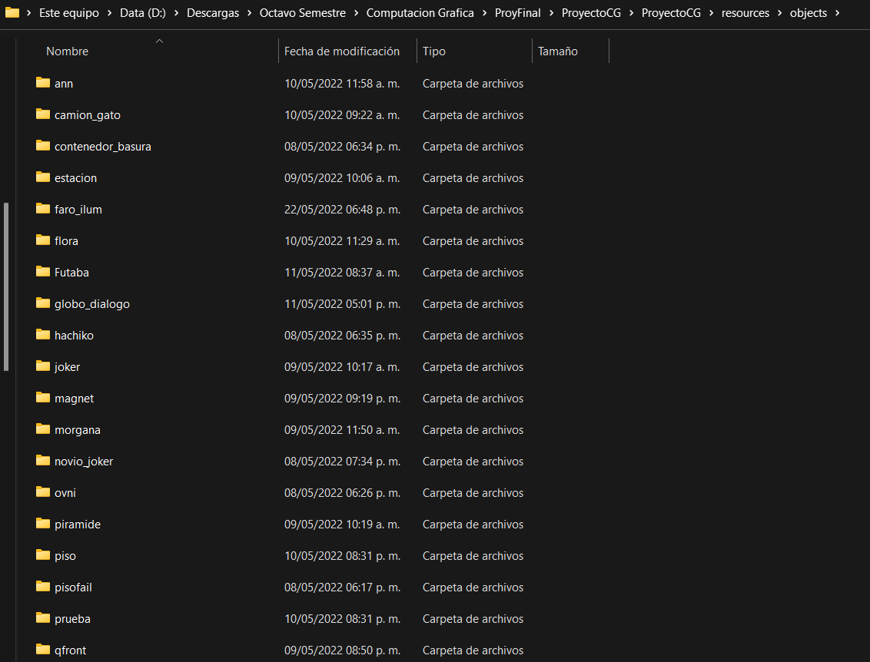

A look at the “resources < objects” folder.

Some models that make use of hierarchy are grouped together in folders. For example, the camion_gato model has the bodywork and wheels linked by hierarchy, and within its folder we can find both models (car and wheels). This also happens with all humanoid models, which have a hierarchy in arms, legs and head.

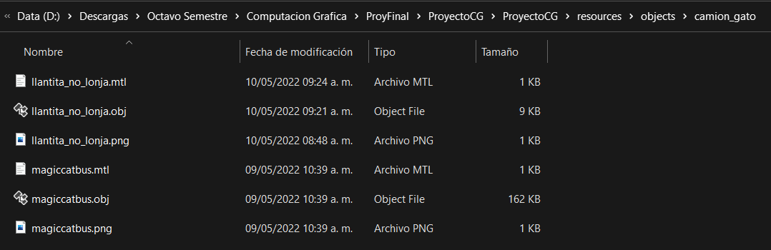

A look at the camion_gato folder, which has 2 models: Bodywork and wheels.

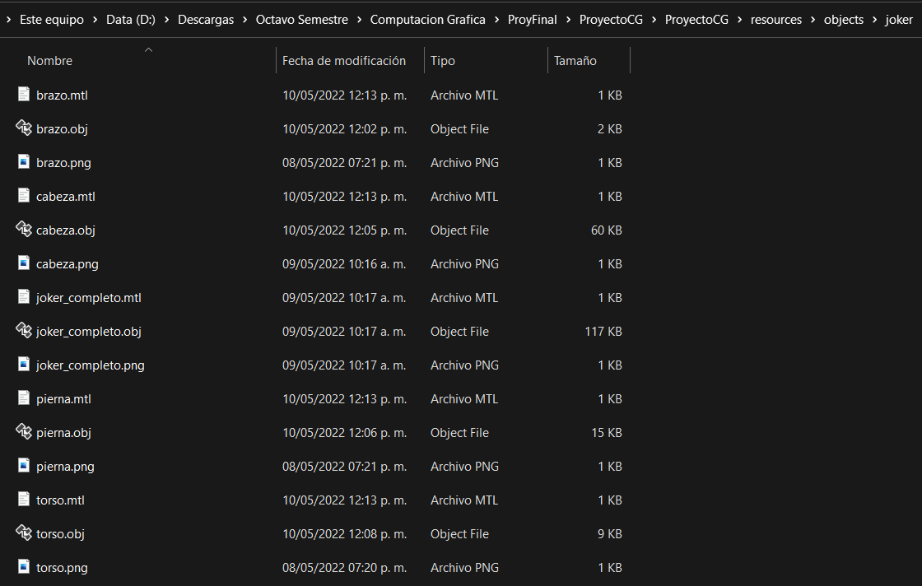

A look at the Joker folder, which has several models that make up the main model and are linked together by hierarchy.

The way to load the models within the project is described below.

We need to add the correct libraries, both to perform mathematical operations and to be able to use models and textures.

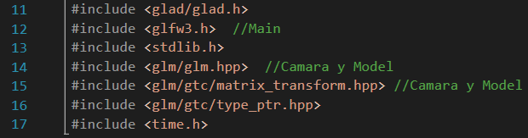

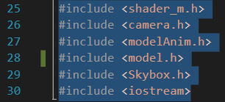

Skyboxes make use of a shader, so it is necessary to initialize that shader.



Once the shader is initialized, we proceed to load our skybox textures and create the skybox objects.

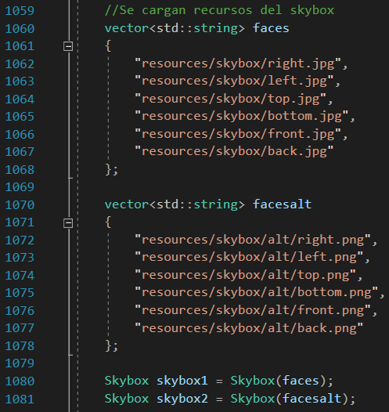

Next, we proceed to use the skyboxes.

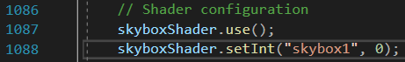

Once in use, we proceed to draw the skybox.

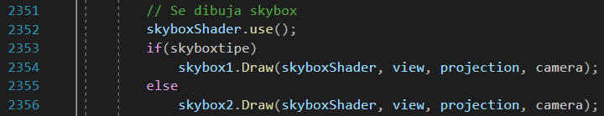

If we want to change the skybox at runtime, we simply press the N key to draw the other skybox.

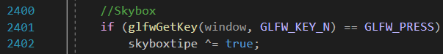

If we close the program, we close the skyboxes so that they stop taking up memory.

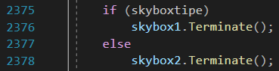

To load the models, we need to load each .obj, have the texture and its material in the same folder for them to display correctly. Later, we can start the OpenGL load of models.

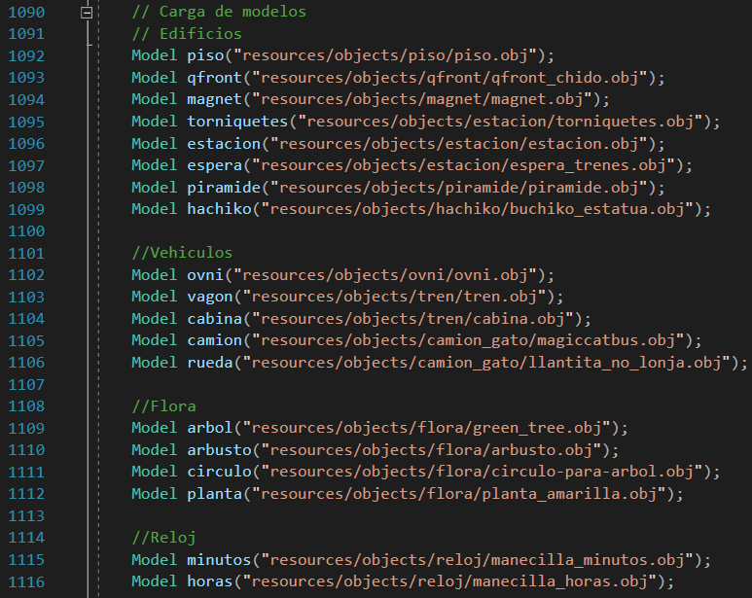

In this part, the hierarchy order doesn't really matter, it only matters to load the models, although we do organize the loading in a certain order to avoid confusion.

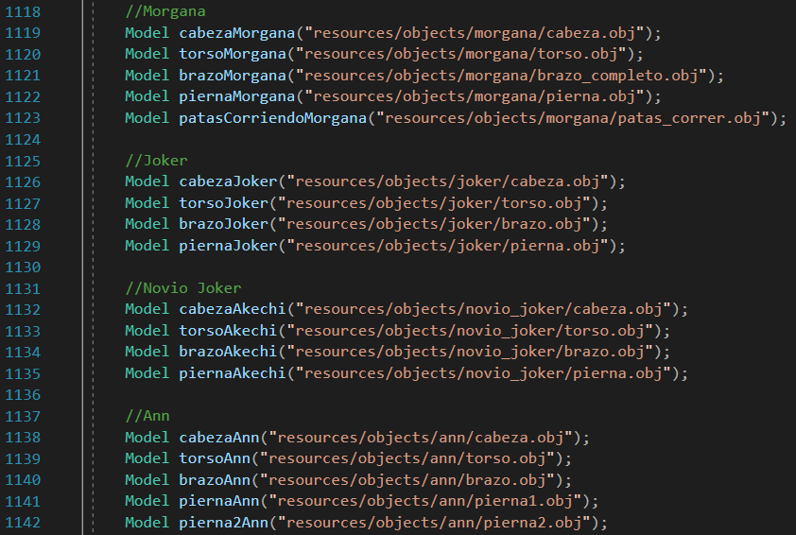

In the case of Futaba, since we are not using an .obj, but a .dae, we initialize an animation shader, because its default animations were obtained through Mixamo. Since there are 2 animations for Futaba, then we load the 2 models with animation.

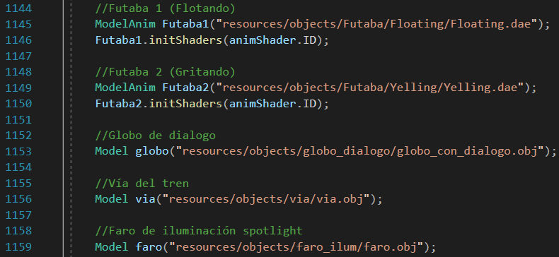

The next step after model loading is to draw the loaded models, but for that we make use of a shader known as staticShader, while for animated models we use the animShader. We need to use them before drawing the models. The static shader is also used for lighting. Once the shaders are started, we proceed to apply geometric transformations, auxiliary matrices for hierarchy implementation and finally draw all the models needed. Due to the constant repetition of some models, we prefer not to show all the drawing code, but parts of it.



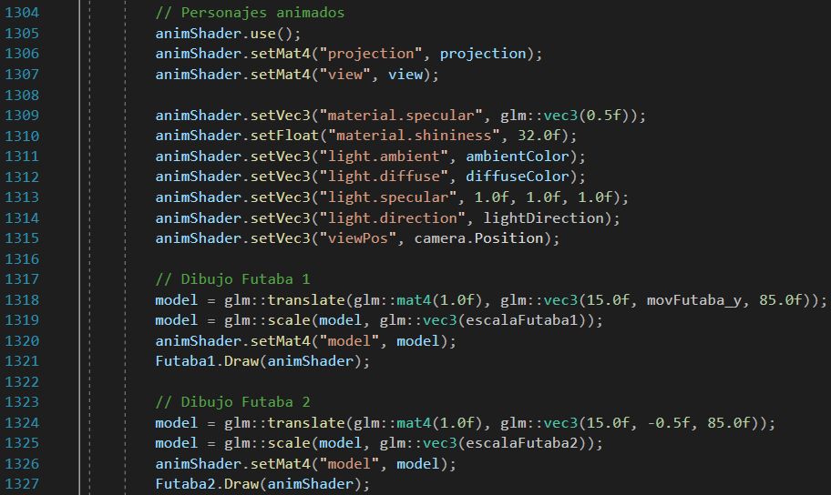

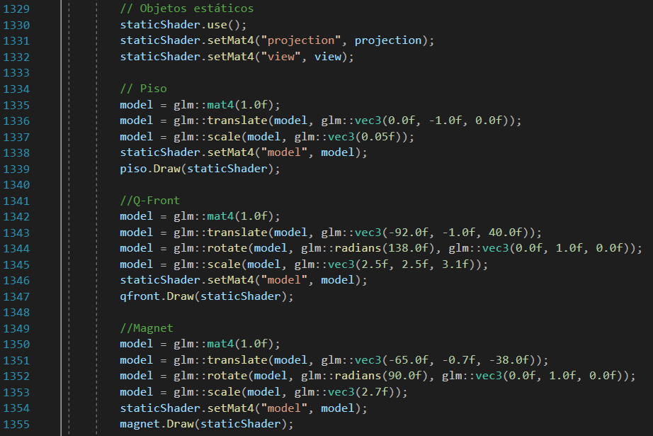

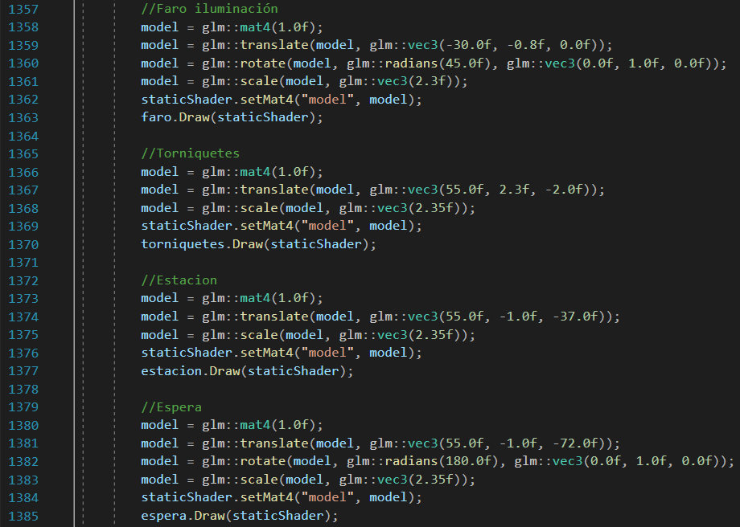

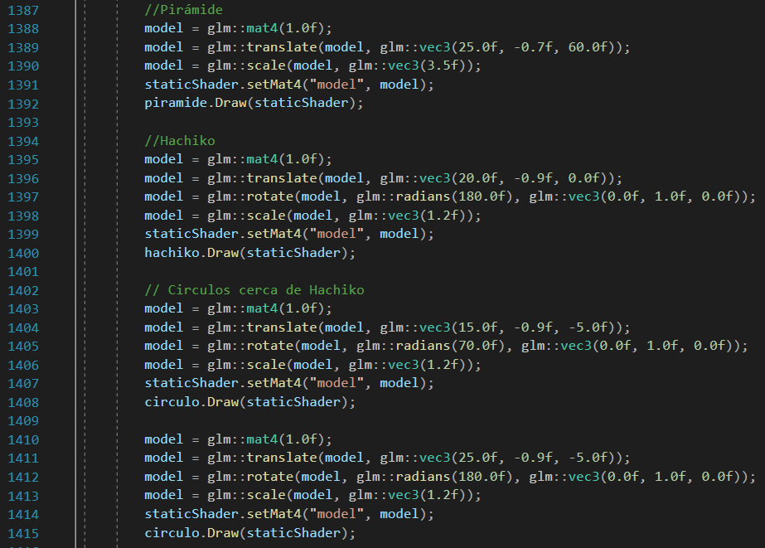

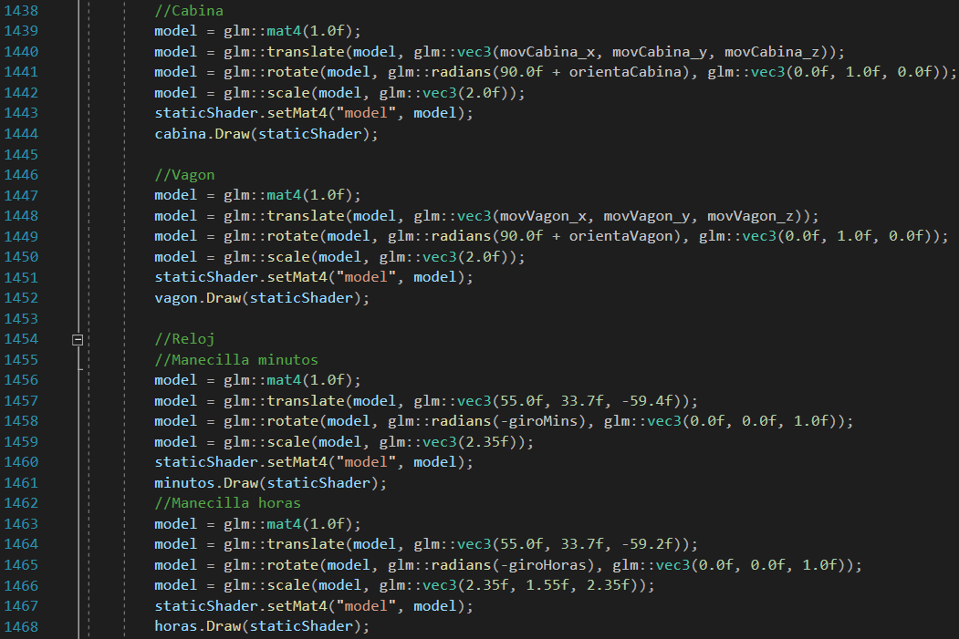

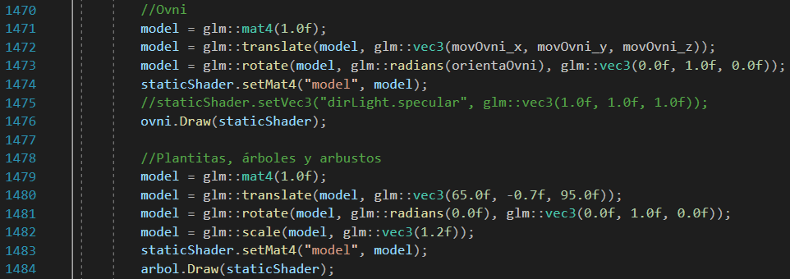

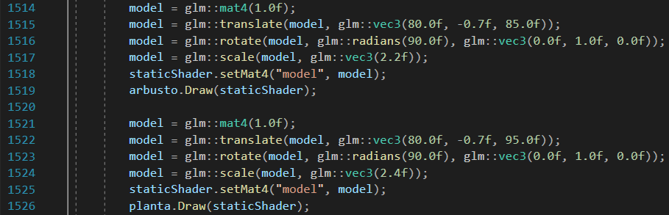

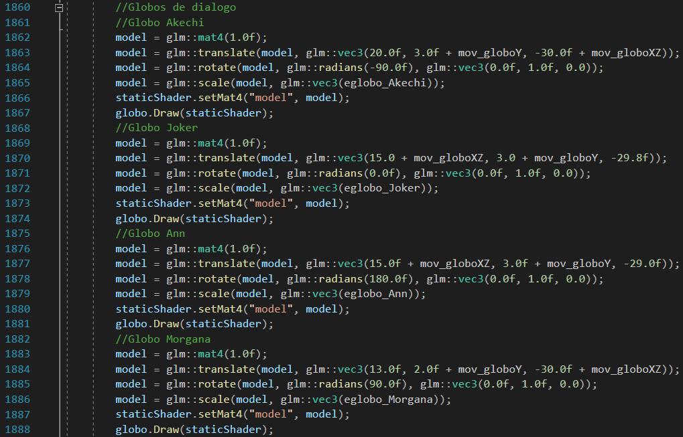

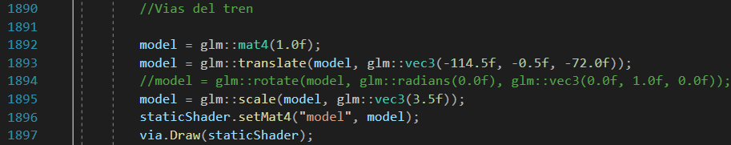

For models with hierarchy, such as the truck, we see code like the following, which is based on taking a model as the main model (in the case of the truck, it is the car body), a temporary matrix is ​​made on that model and that temporary matrix is ​​used for the drawing of the other parts (the wheels, in the case of the truck). This sets up the hierarchy.

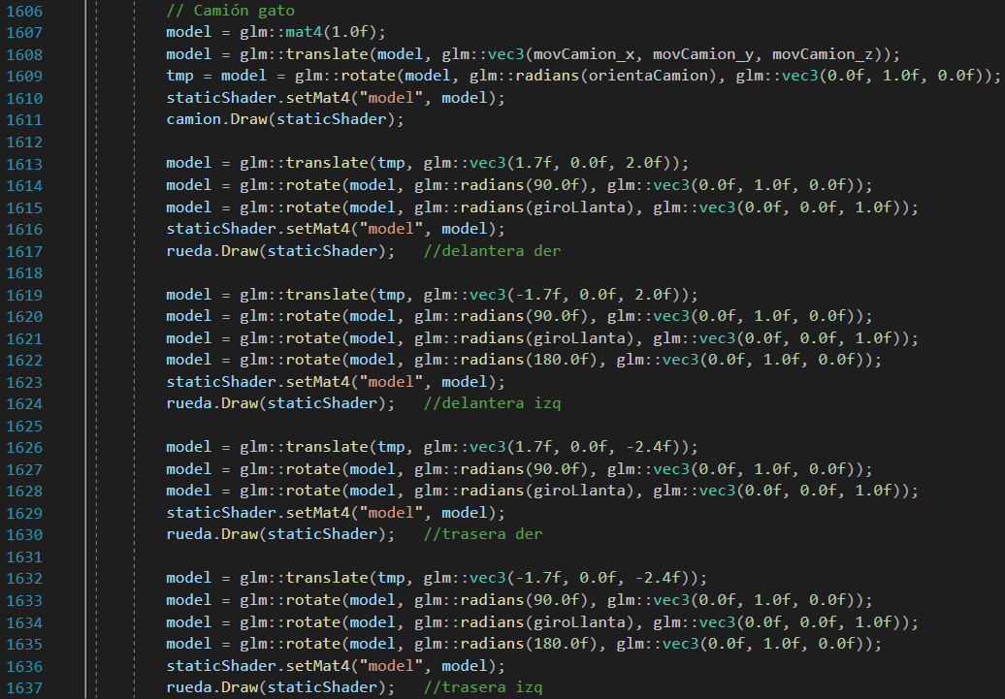

For Morgana we have the following code.

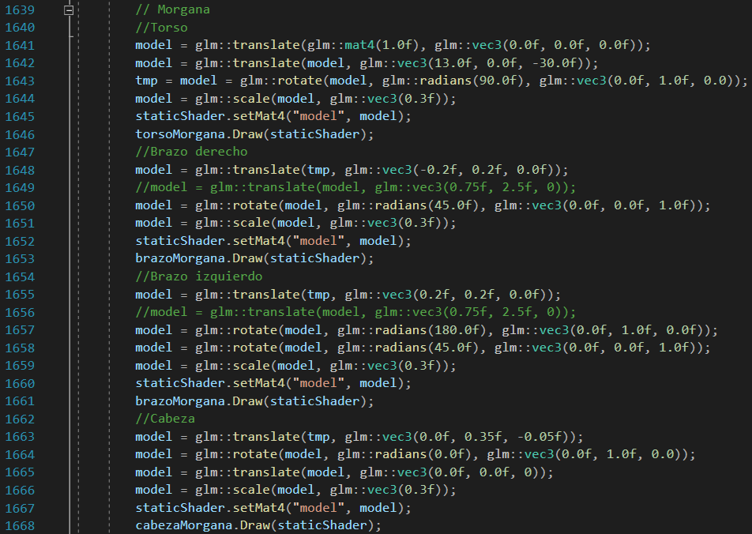

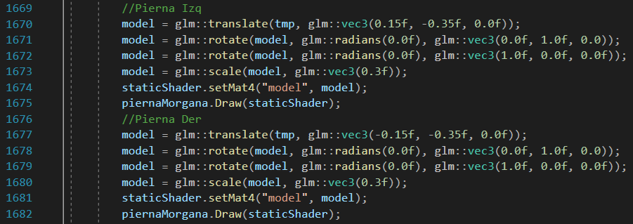

For the other characters, we have a fairly similar code structure:

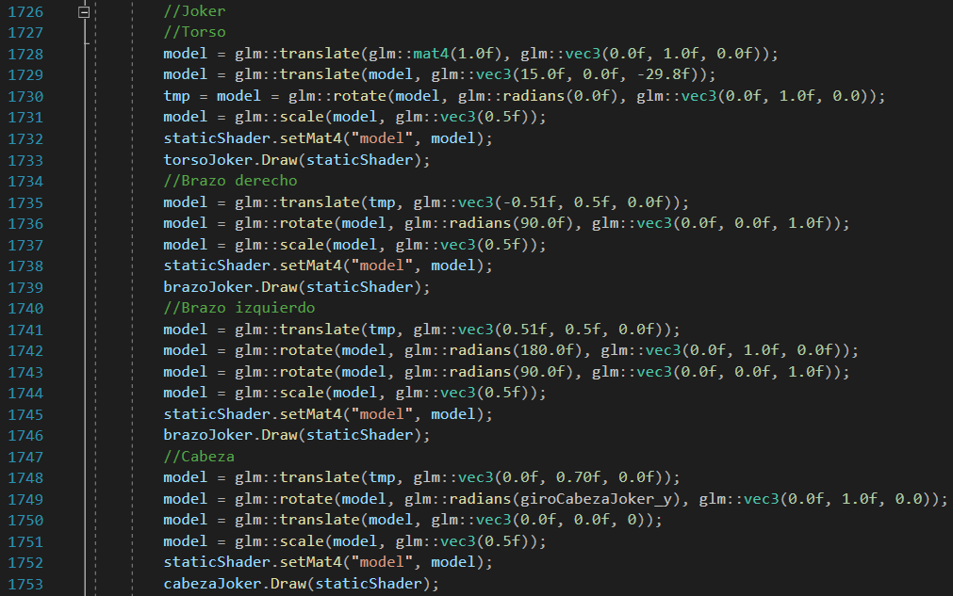

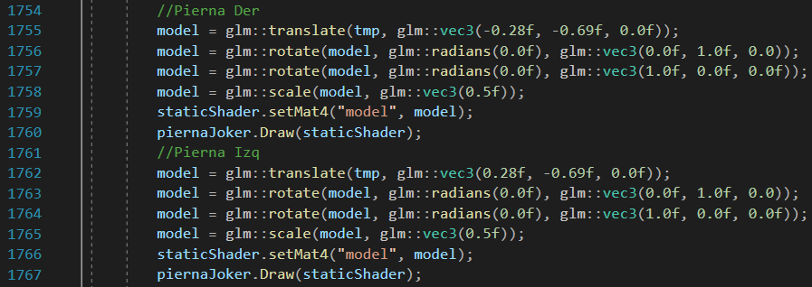

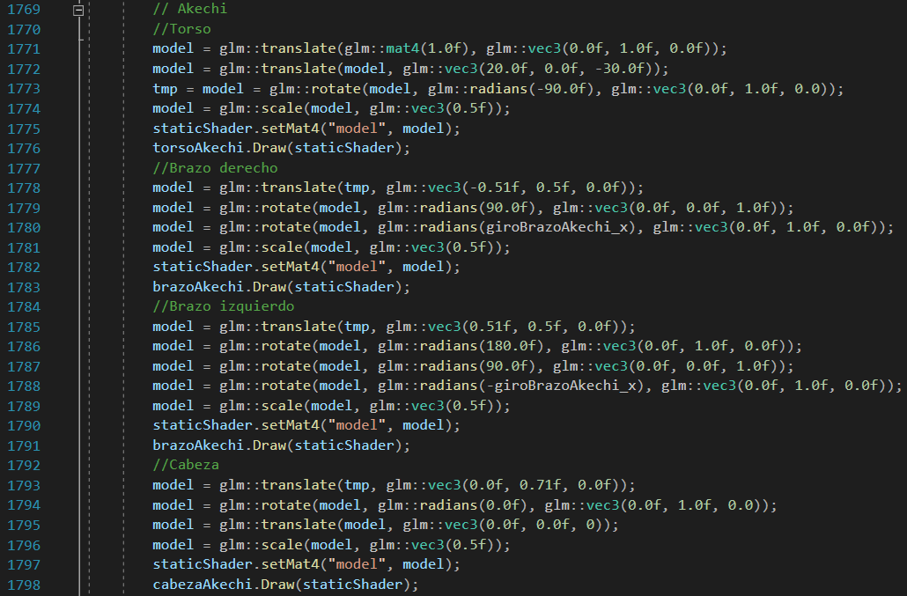

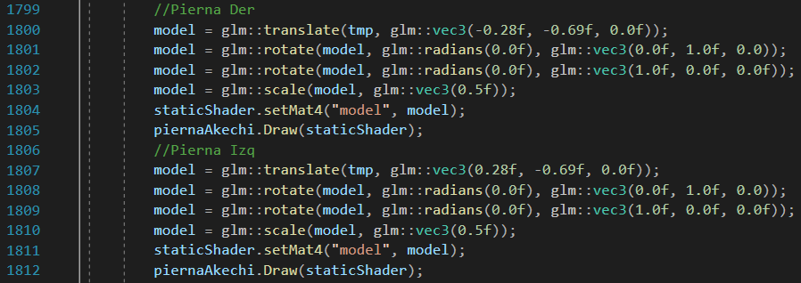

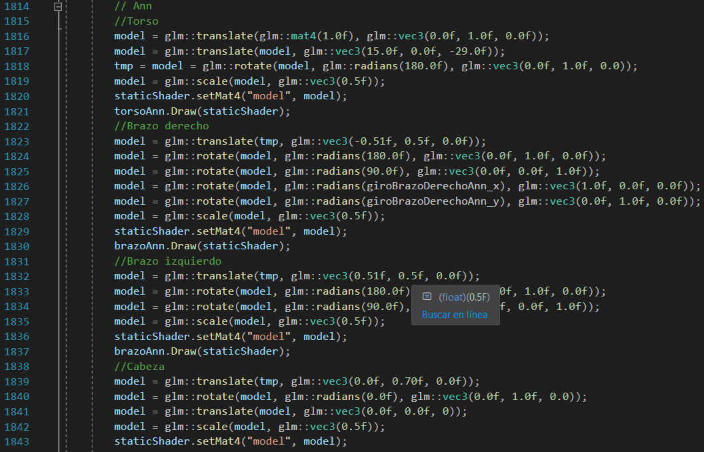

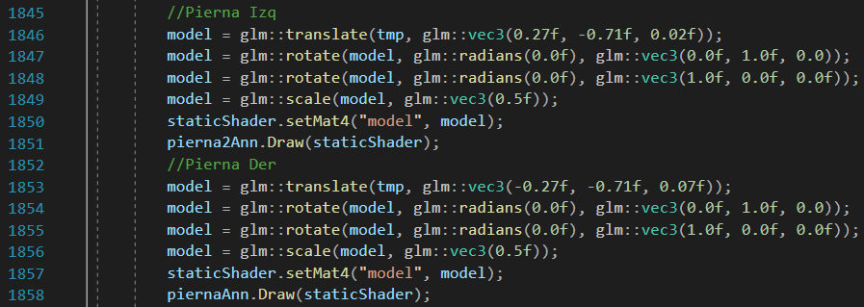

Basically, this is the drawing method for all models. Some have slight variations in the shaders because they are animated (like Futaba). Also, some variables can be seen in geometric operations, since these variables will allow us to create animations, as described later.

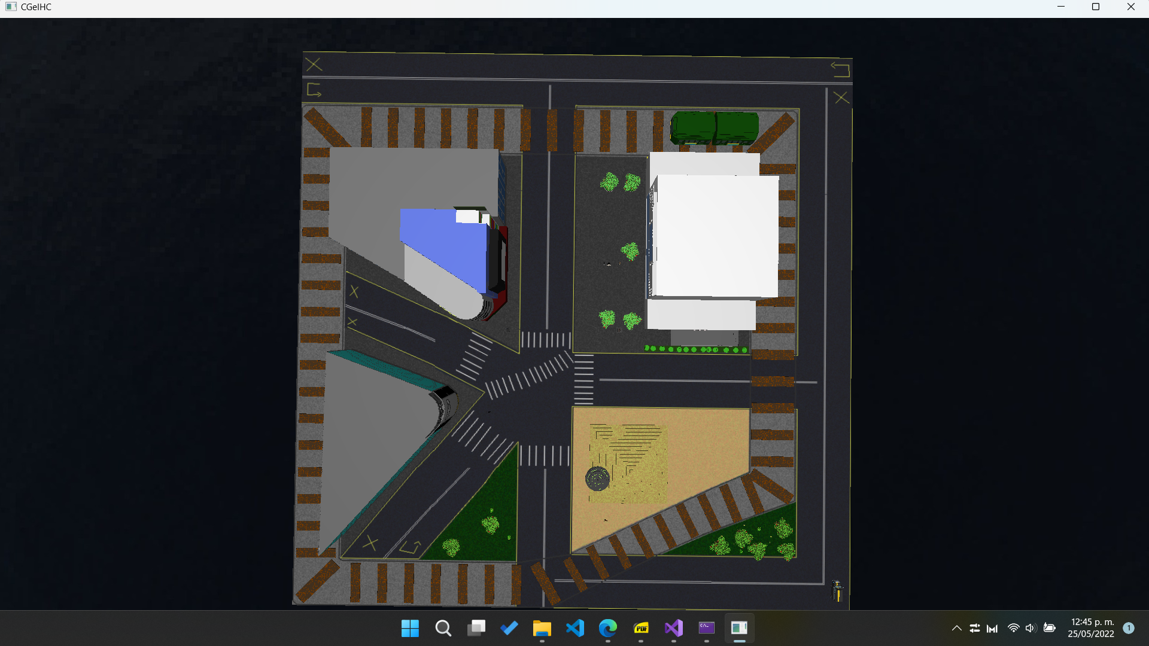

Vista aérea de los modelos.

Aerial view of the models.

# Traveling

For this section, the implemented cameras are taken into account (especially a camera linked to the floor). We have 3 cameras:

* Main camera, which has free movement in all axes. This allows you to move freely around the entire stage from different points of view.
* Camera linked to the XZ plane, or floor camera. This camera has a very slight elevation, near the floor, but does not allow you to move vertically across the stage.
* Aerial camera. Automatically, advances to the center of the stage, but with a great height and looking down. This allows you to observe all the elements of the stage.

The implementation of these cameras comes from the camera.h library, found in the include folder of the project.

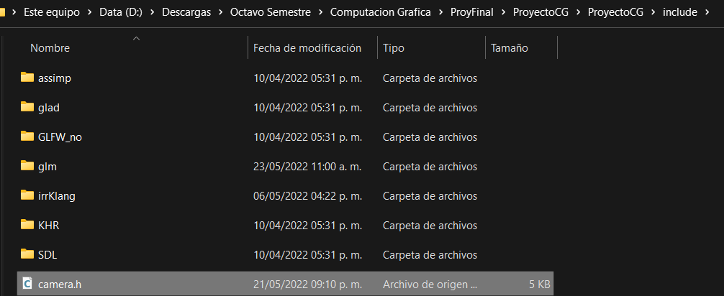

It is included at the beginning of the project.



With this, we create our camera object and our variables to handle the position and angles of the camera.

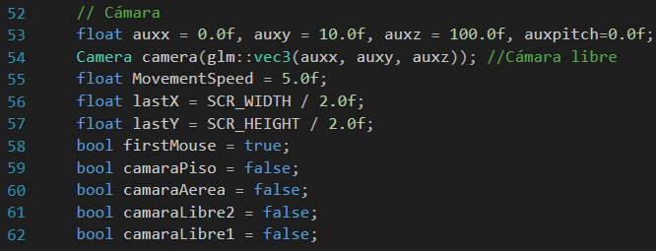

Likewise, we have our functions related to the mouse to be able to control the direction of the view and thus also modify the camera movement direction.

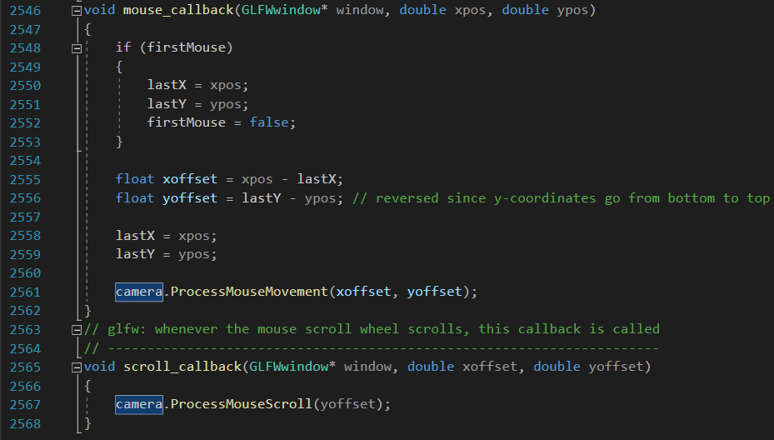

And so we have our main camera.

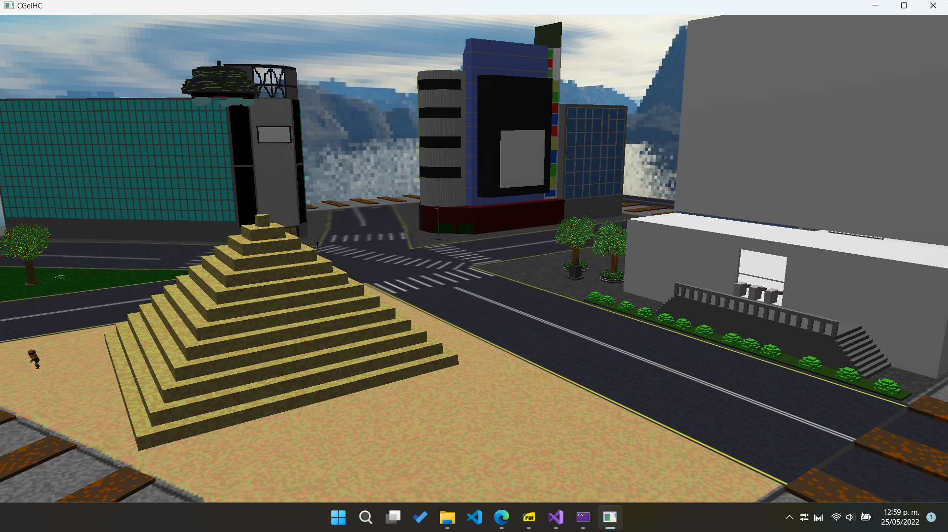

Free camera sample

For the floor camera and aerial camera, we assign the keys C and K, respectively. When one of these booleans is activated, the camera will have the behavior described above.

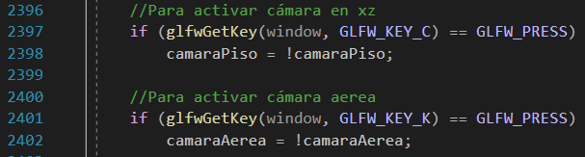

The way these booleans affect the behavior is in the render loop of the project.

If we activate the floor camera, then the position on the Y axis will always stay at a very low height, but it is possible to move in X or Z. Instead, for the aerial camera, it stays at a very high position in Y, without the possibility of moving in X, Y or Z, and always looking down.

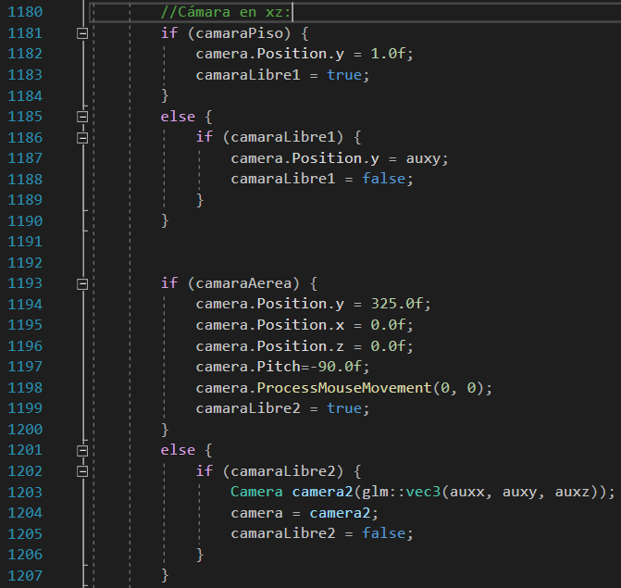

The ground and aerial cameras will look like this:

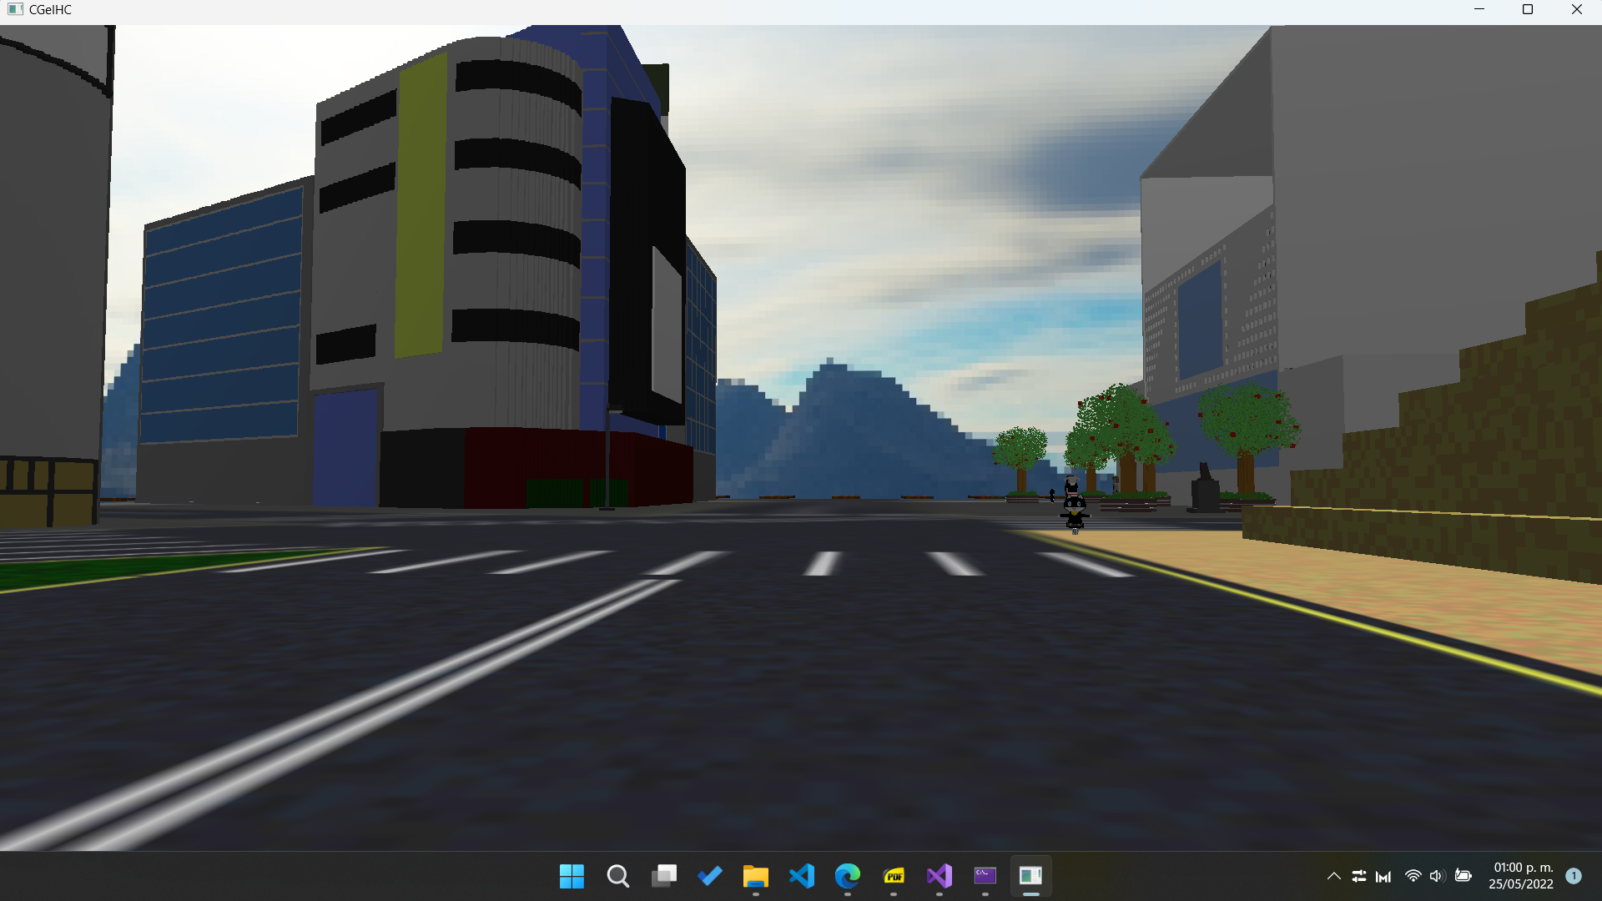

Floor camera sample

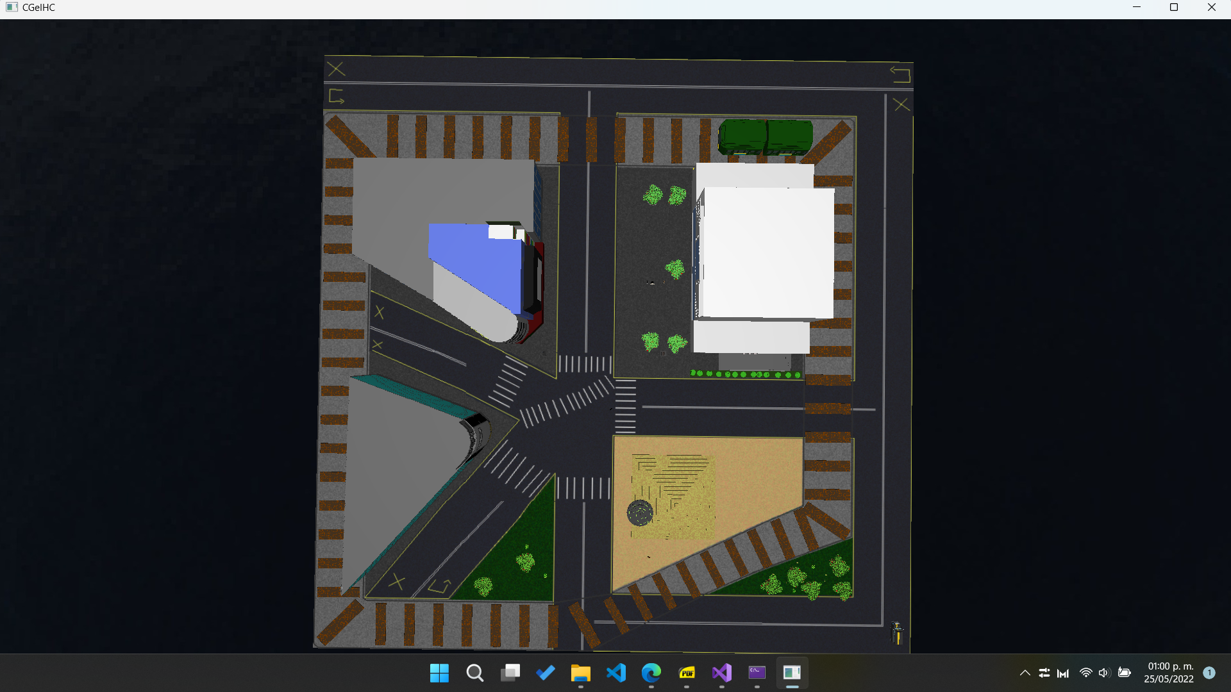

Aerial camera sample

# Illumination

For the illumination we make use of the staticShader. The first thing to do is to use that shader and then we put our directional light (we have 1 directional light, 2 spotlight type and 3 punctual lights).

For the directional light we set our camera as the reference point and indicate that we want the direction to be downward in Y and negative in Z (that is, that the light goes in the direction of the camera). Subsequently, we modify its ambient, diffuse and specular components.

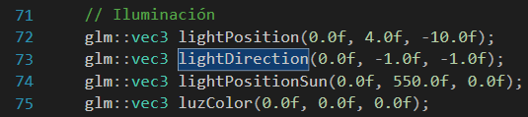

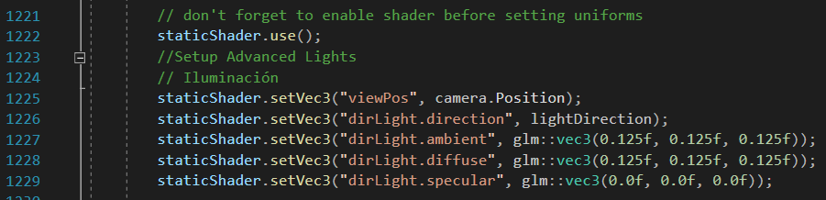

For the punctual lights, we have one that simulates the sun and another 2 that go in front of the truck (in its headlights). The procedure is the same for all of them: We give them a position in the environment, we modify their ambient, diffuse and specular components, as well as we modify their constant, linear and quadratic values, so that they cover a greater distance or greater intensity in illumination.

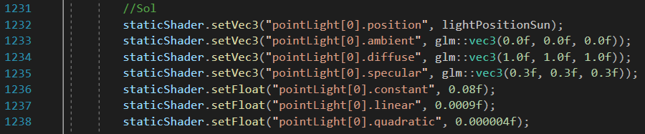

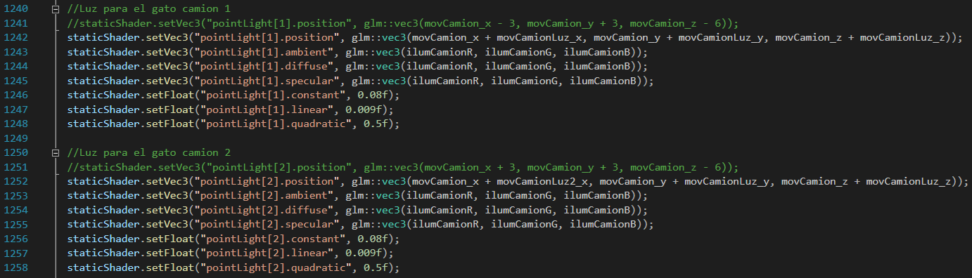

The punctual lights are appreciated like this in the truck, although it is difficult to appreciate the light of the Sun in an image:

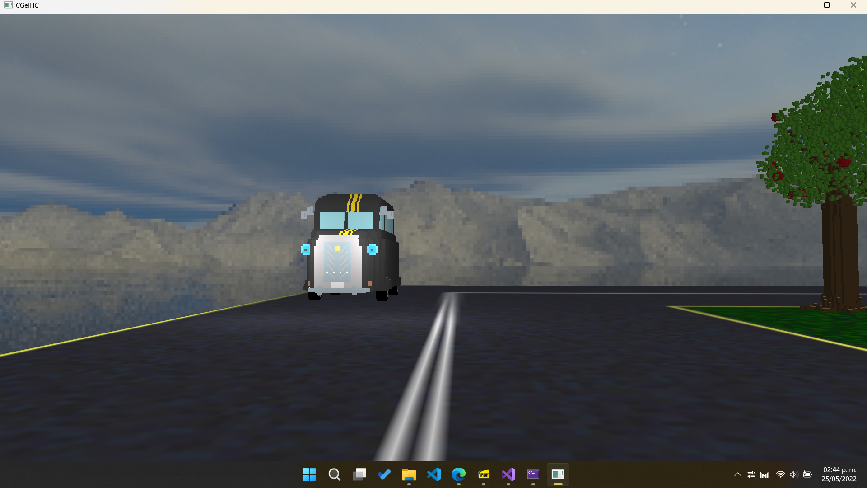

For our spotlights, the procedure is quite similar to that of punctual lights, but with some extra parameters, such as the cutoff and outer cutoff. Also, we assign a direction to them (in this case, the two spotlights point downwards).

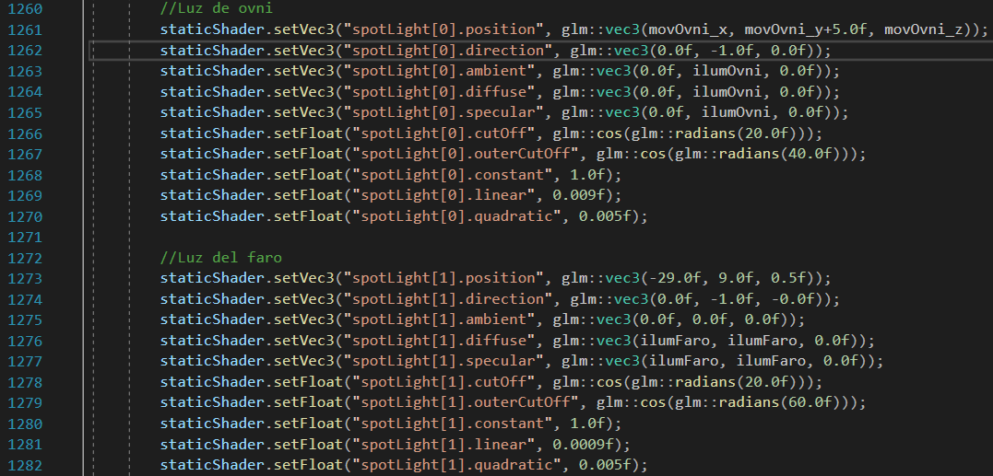

The spotlights will look like this:

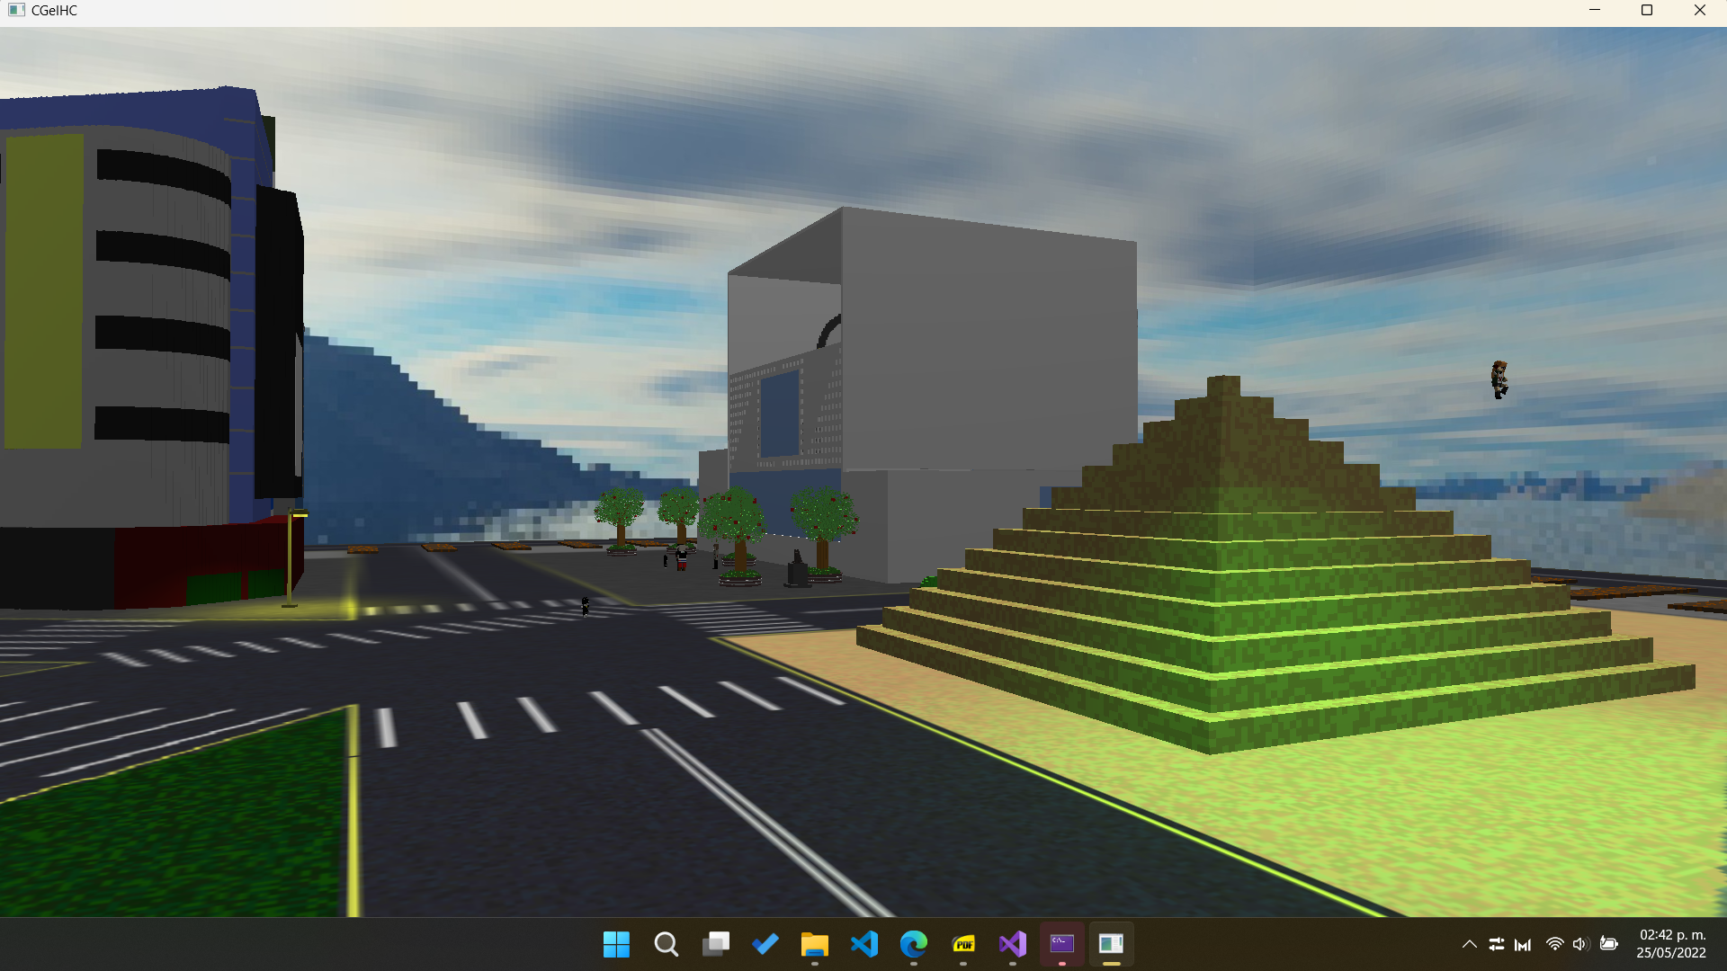

As seen in previous screenshots, the lights have values inside some variables, and the truck's spotlights are "turned off" (values of 0). These lights will light up when triggering animations and reaching certain states. Though the beacon light will be turned on/off by pressing the F key.

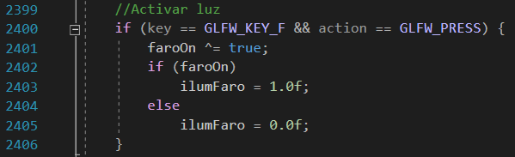

For the truck, the lights will turn on in most states:

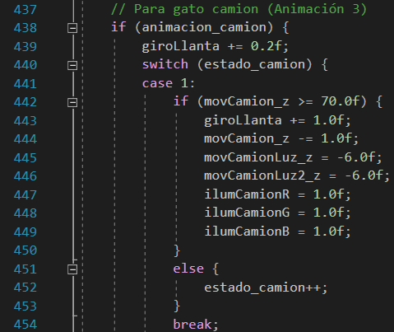

For the UFO, the spotlight will turn green when it abducts and returns Futaba.

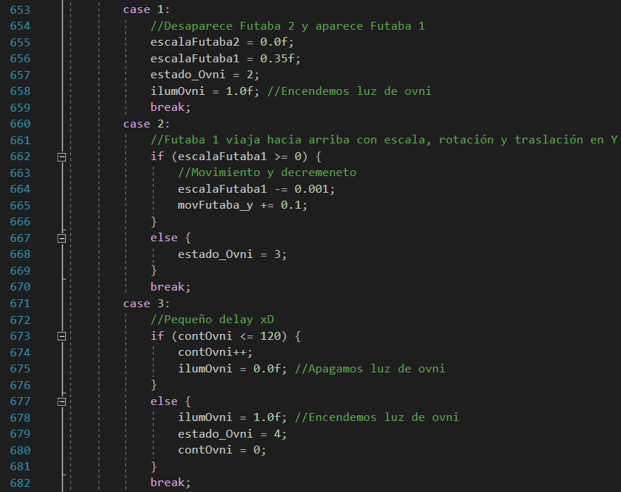

And the sun will move when its animation is activated:

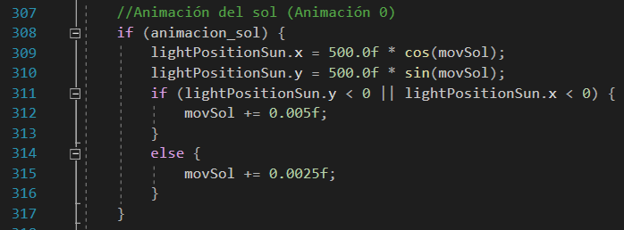

# Animation

In this section, we have 8 animations, of which 1 uses the keyframe method, most of these animations are basic animations (based on transformations and flags) and a few others are complex or advanced. For more information on what can be observed from them, read the user manual.

Starting with animation 0, according to its assigned key, it is the movement of the point light that acts as the sun. Pressing the 0 key activates the boolean that allows the execution of the animation in our animations function (animate) that is executed in the execution loop.

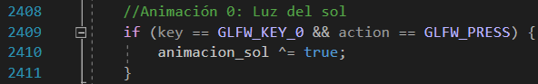



This animation consists of the sun traveling, by means of a formula, in a circular path in the X and Y axes, along the stage. When the sun is above the stage then it will go slower, but if it goes below the stage it will move twice as fast.

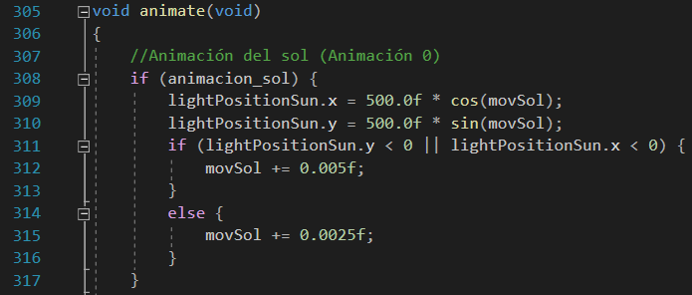

For animation 1, we have clock hands at the train station. The minutes hand moves at one speed and the hours hand moves at 1/12 of that speed. It is activated by pressing the key 1. Pressing this key also resets the start values.

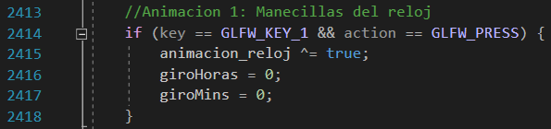

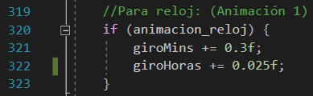

For animation 2, we activate it by pressing the 2 key. Likewise, we put the initial values.

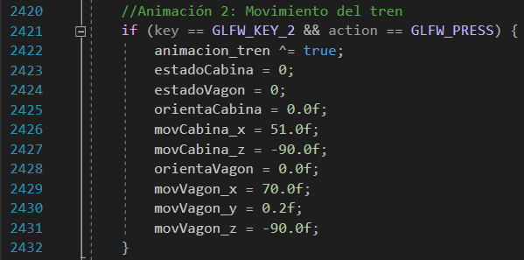

In this animation we will see the train moving around the stage. It consists of 5 states, although it should be noted that this occurs for both the wagon and the cabin.

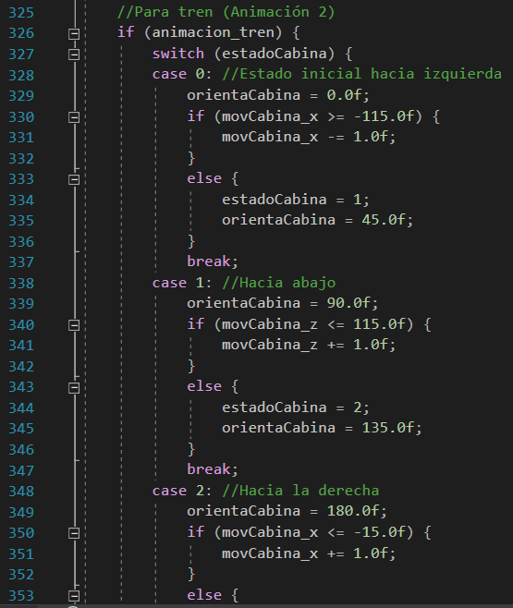

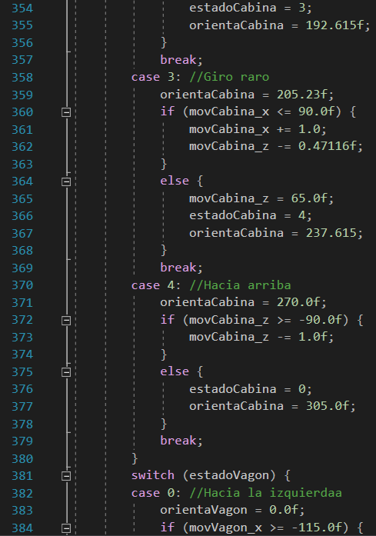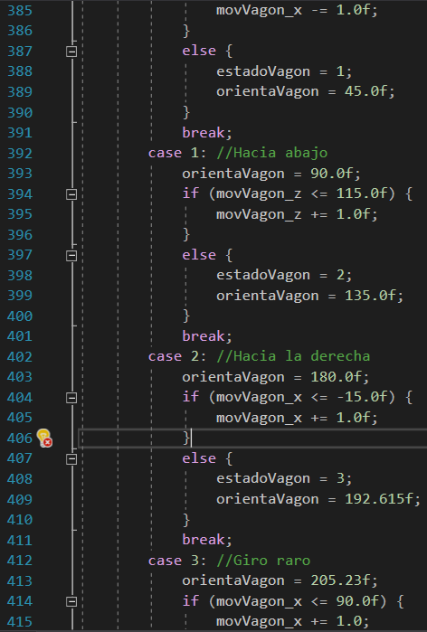

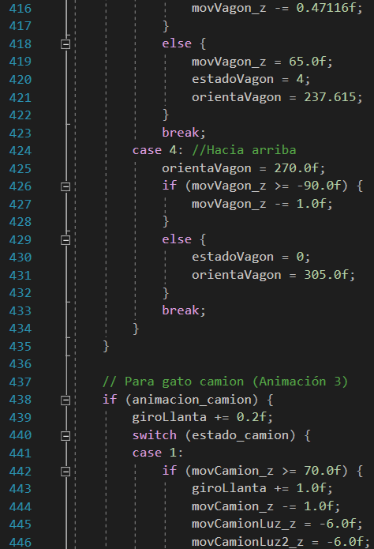

For animation 3, we activate it by pressing the key 3. As with the previous ones, we have a reset of the variables each time we press this key.

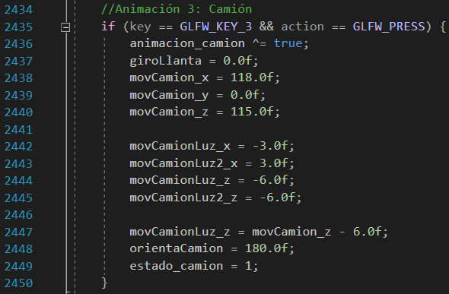

Once the key is pressed, we proceed to start the animation, which consists of 12 states. In those states, except the ones which involve jumps, we see that there is a point light in the truck's headlights.

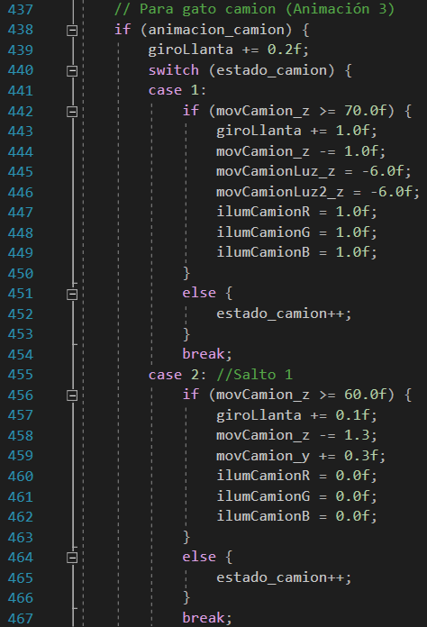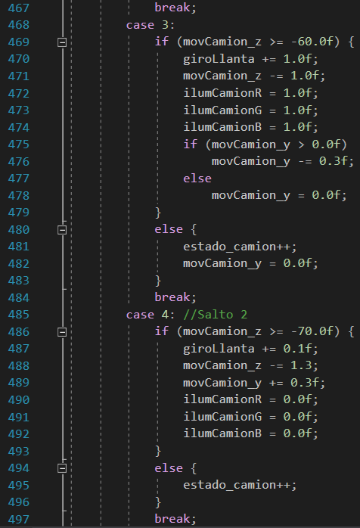

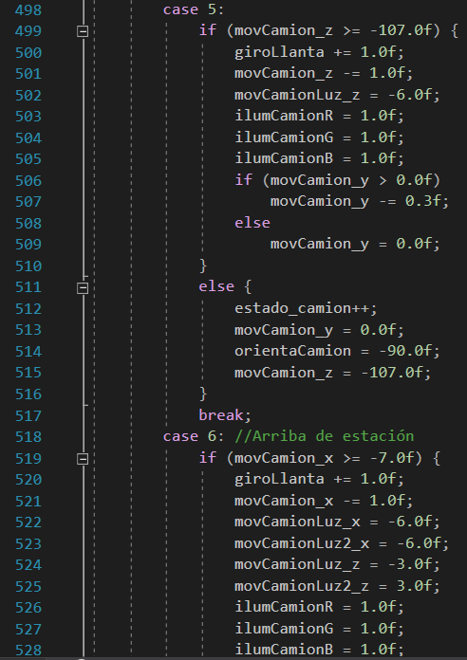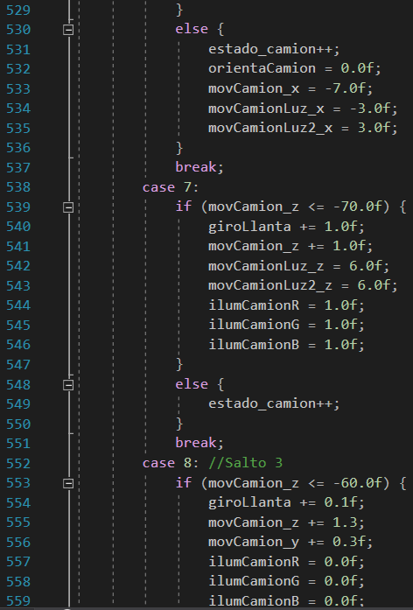

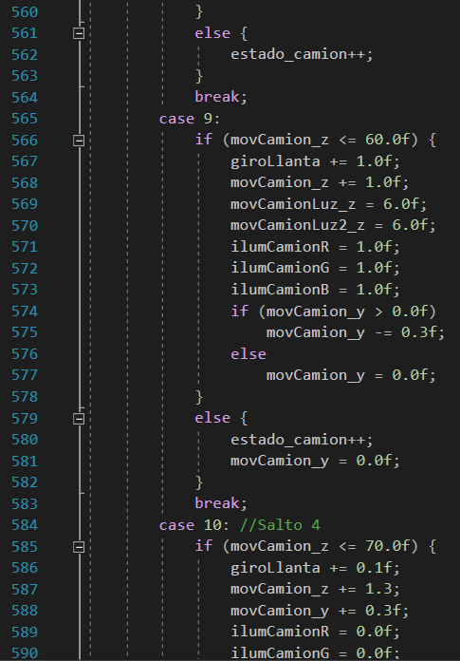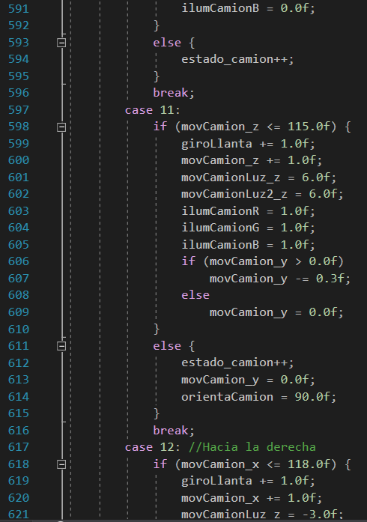

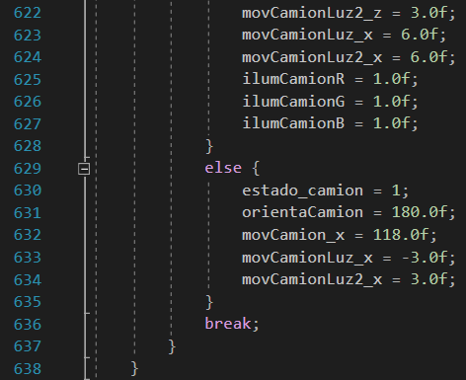

For animation 4, the UFO anmation, we have a total of 7 states. This animation involves a spotlight. It is turned on with the key 4 and restarted with the O key. In any case, the UFO will always be rotating.

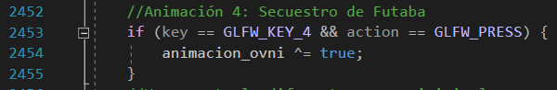

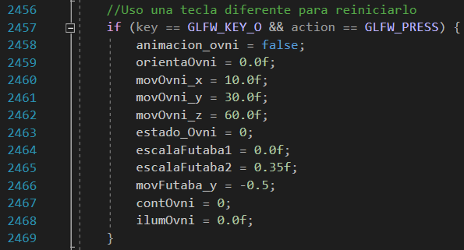

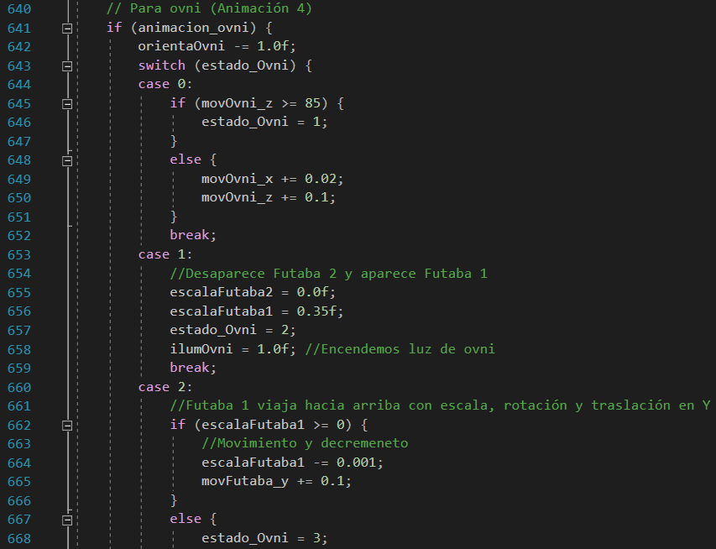

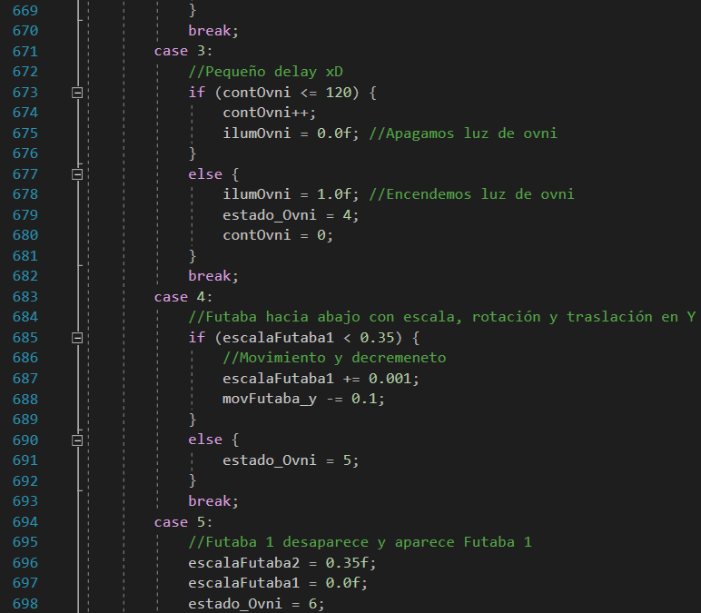

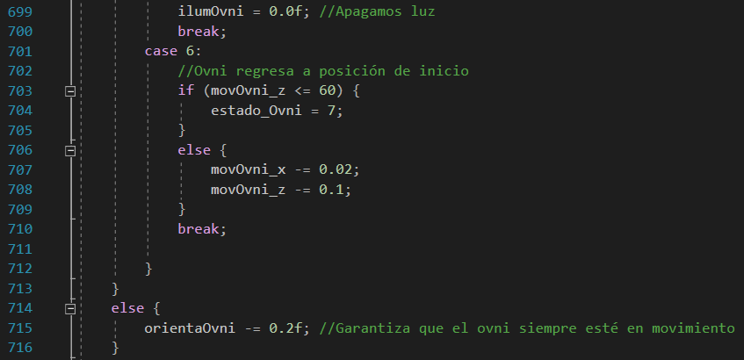

In the case of animation 5, we have more complexity, since it is made with the keyframes method. For this, several functions are needed. The first thing we show is how it works: When we press the key 5, the animation starts, starting with the first frame, we interpolate and advance from frame to frame.

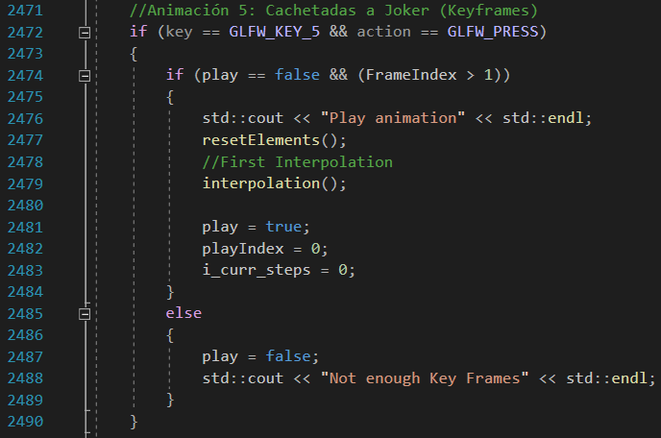

What we do here is to define the structure of our frames, we create an array of frames that will save the values ​​that we think are convenient and then we create a function to save frames.

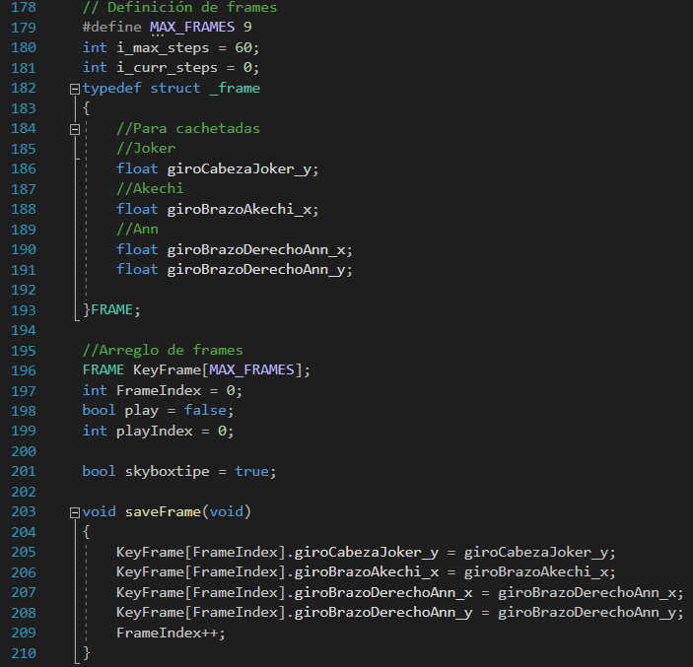

Likewise, we have our function to assign values ​​already obtained to each frame:

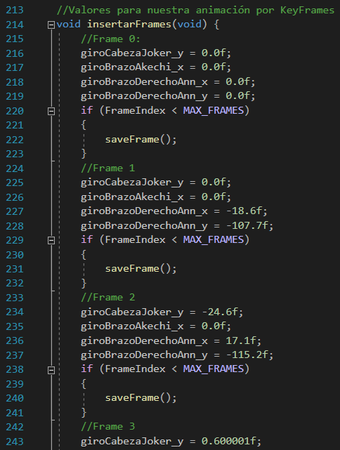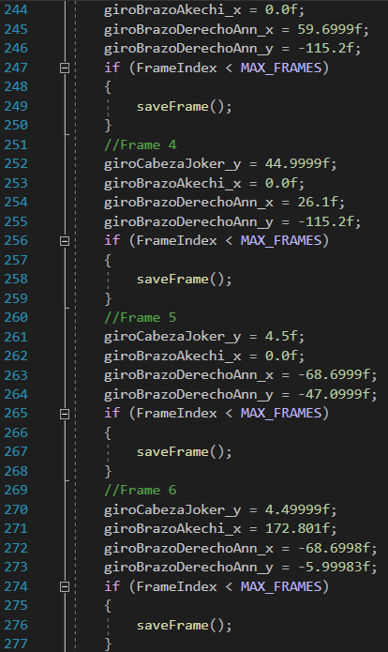

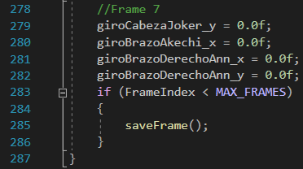

Once we have these values, we simply have to interpolate and play them.

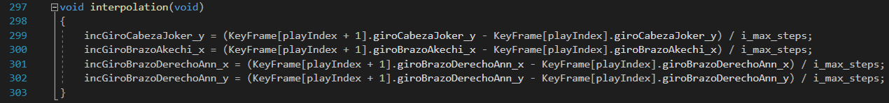

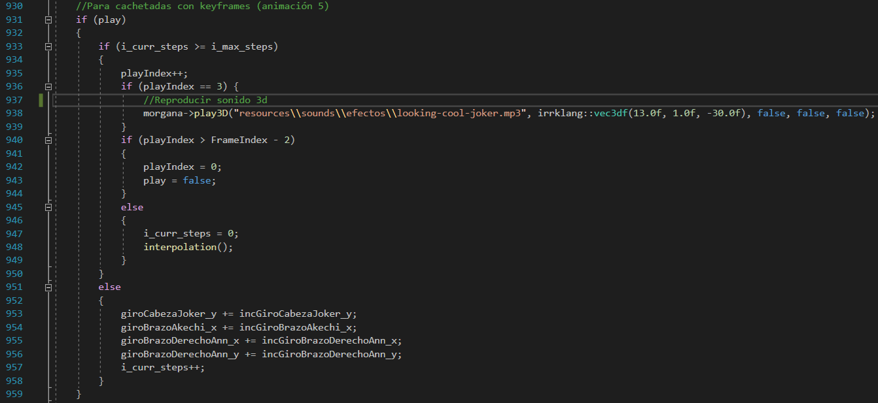

Likewise, as seen in the last image, we see that there is a 3D sound. This is played upon reaching the 3rd frame.

For animation 6, activated with the key 6, we have speech bubbles that appear above the characters. Speech balloons essentially change their scale and rise on the Y axis. Also, the animation can be restarted with the P key.

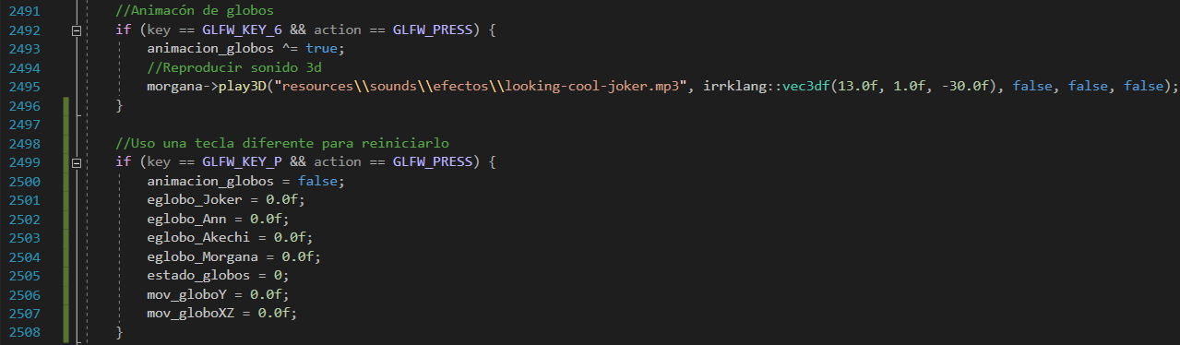

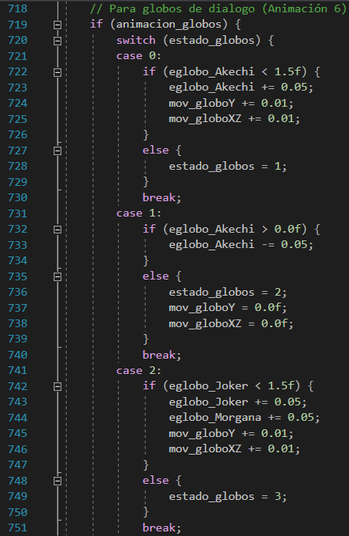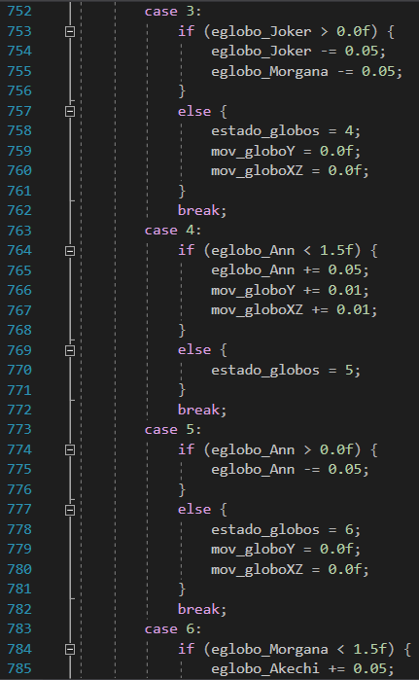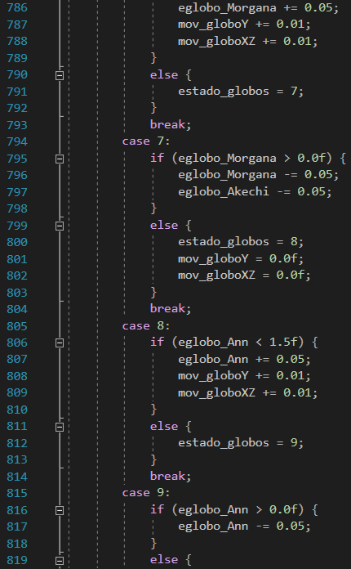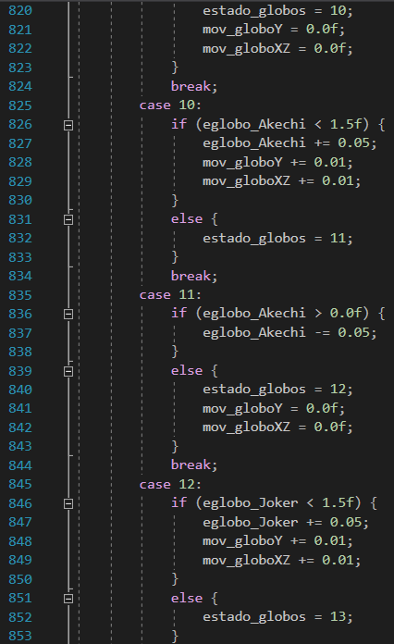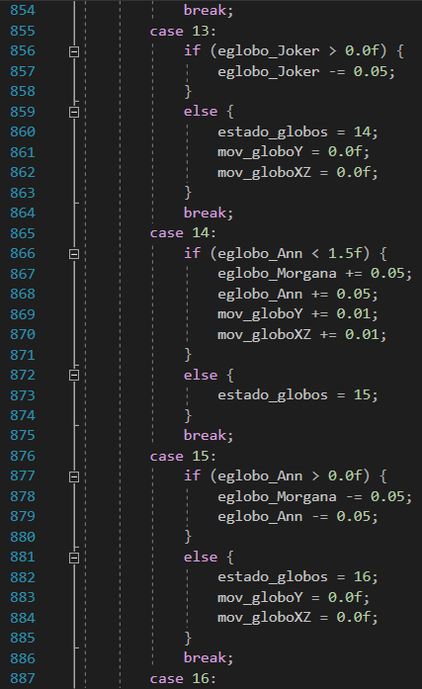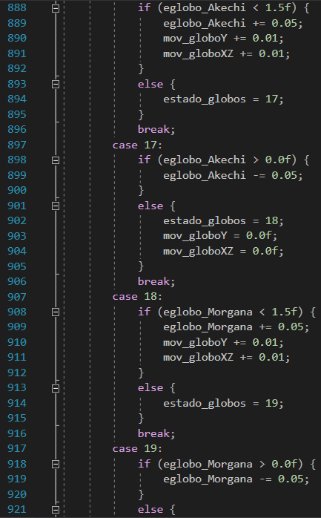

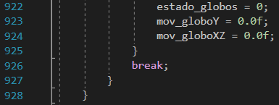

Finally, for animation 7, activated with the key 7 and restarted with the L key, we have Shadow Morgana running in circles around the crossing. It also raises and lowers its arms to simulate the shock of running fast and always looks in the direction where it is running. This animation relies on mathematical formulas.

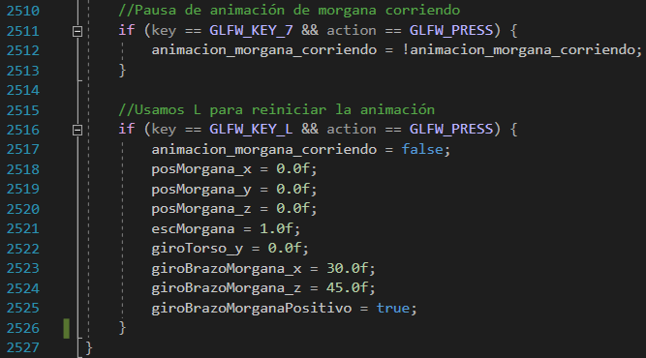

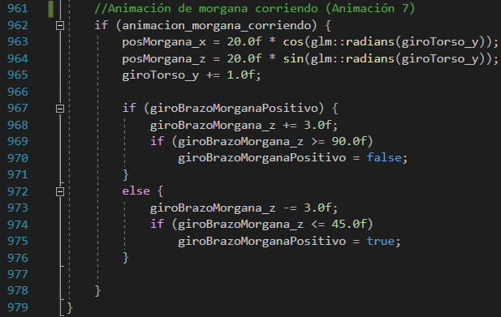

# Audio

In the case of audio, the irrKlang library was used. The first thing was to download the necessary files and add them inside the project folders.

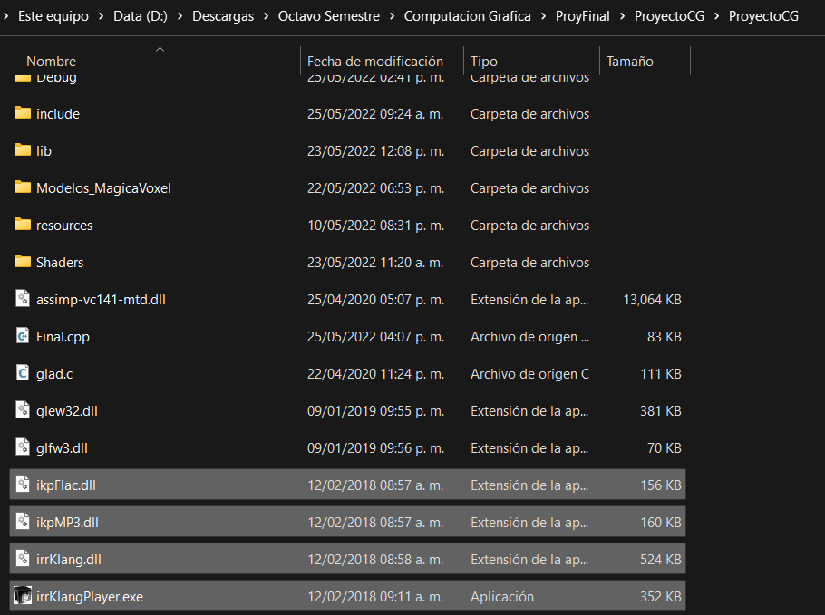

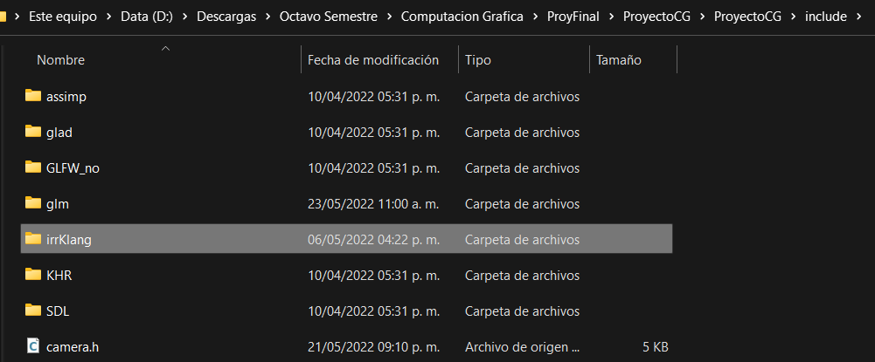

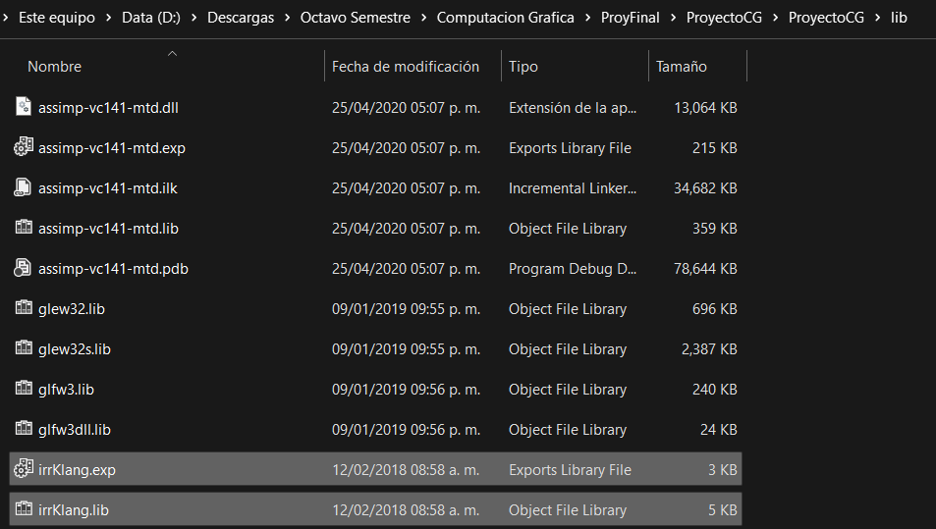

Next, we add the library to our code:

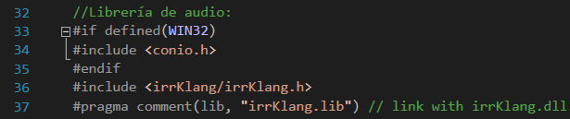

We start the audio engines, one being dedicated for background music and the other for sound effects, and if one engine fails, we send an error:



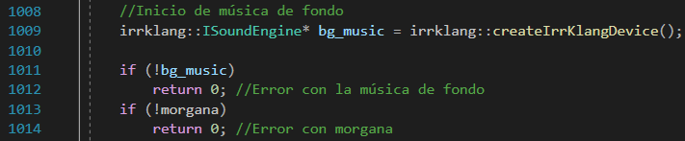

In the case of background music, it is played when the rendering starts. Meanwhile, Morgana's voice effect plays on certain events (such as animations or pressing the 6 key).



Since Morgana's sound is in 3D, you need to constantly update the hearing position for the sound to be heard correctly:



Once we end the program, we free the memory of the audio engines.

